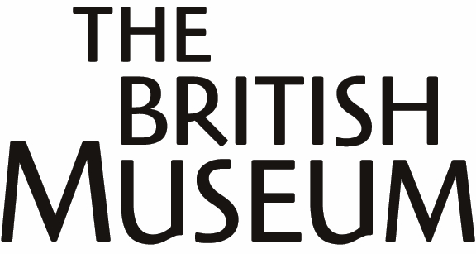

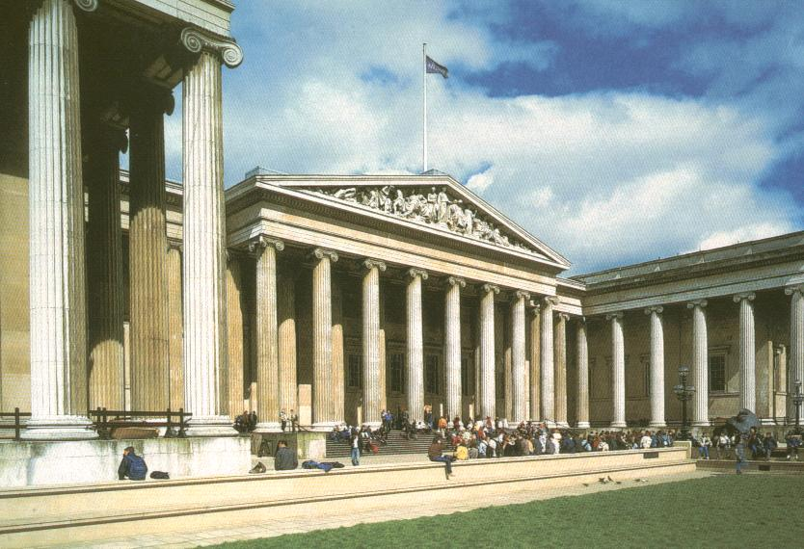

Tours for adult ESOL
students

Information
for tutors

CONTENTS

- Who are the tours for?

- Practical considerations

- Planning the visit

- Pre-visit classroom activities – some ideas

- What will students do in the Museum?
- introductory tour
- work in the Africa Galleries

- After the visit
- evaluation
- other suggested follow-up work

Notes for ESOL class tutors

1. Who are the tours for?

The tours are for adult students on ESOL courses at Colleges, with Life-Long Learning providers, or with Training Providers or Voluntary Sector providers, aimed principally at students at national ESOL levels Entry 1, 2 and 3. However, students studying at Level 1 and Level 2 may also enjoy and benefit from the tours.

This ESOL information can be used both to support independent visits to the museum and as background to tours led by museum staff.

2. Practical considerations

Many students can find a museum visit overwhelming – especially if it is their first such experience, so careful planning and support are needed if the learning outcomes of the visit are to be realised.

Role of the British Museum guide

With this in mind, the trained staff from the Museum’s Education Department who lead the tours aim to make the experience informative, enjoyable and with a manageable level of new information.

Role of the ESOL class tutor

The success of your visit will also depend on how the visit is integrated into the students’ classroom work, through planning pre-visit activities, explaining to the students what the visit will entail (what they will see, and what they may not see) and planning relevant follow-up activities.

It is also important that the ESOL class tutor takes on an active and participative role on the tour, assisting and supporting the students as necessary, especially when the students are working in the African Galleries.

You are welcome to spend extra time in the museum. Some ideas for how to structure this are given below.

Format of the tours

The guided tour is 90 minutes long. Groups are asked to arrive 10 minutes before the start time. The group will then be taken to the base room, where the visit will commence.

Photography

Students are welcome to use their cameras and videos in the Museum, except where indicated to the contrary. However, it would be greatly appreciated if this could be limited to their own time within the museum and not within the guided tour.

Mobile phones

These must be switched off inside the museum.

Children

Students may bring their children on the visits, provided that they take full responsibility for supervising them and for ensuring that they do not distract the rest of the group.

Access and support

Wheelchair access – there is full access into the Museum, and throughout the guided tour. For lift access to upper floors, please ask an attendant. Please inform the Museum of wheelchair users when making the booking.

Students with hearing or visual impairment – There are facilities for students with hearing or visual impairments. Please discuss your requirements in advance with a member of the museum staff.

Students with learning difficulties or mental health issues - please inform the Museum when making the booking. The tour can be adapted to meet the needs of the group.

3. Planning the visit

Topic and context

Students should understand that the visit is an integral part of their language course. It is an opportunity to continue learning in a safe environment outside the classroom, in the context of stimulating and exciting objects.

Scheme of work

When including the visit in the course scheme of work, many of the component skills from the Adult ESOL Core Curriculum can be covered, and a broad range of language skills work can be offered through practising all five language skills.

Language skills

Extending listening and reading skills: students will be able to listen to a sympathetic speaker giving information on topics on which the students have had some preparation.
The Museum guides will present oral/aural and written information, with graded language, and with information, ideas and concepts simplified, according to the students’ language level.

Students can also extend their speaking skills, with sympathetic listeners, through asking questions and discussion with the Museum guide, the ESOL class tutor and one other.

The work in the African Gallery offers structured writing practice. This can also take place as part of the follow-up class room work.

Throughout the visit students will be extending their study skills, through formal oral/aural presentation, understanding a variety of written presentations, and recording the information presented to them.

They will also be developing skills in how to enjoy and learn from a museum collection.

Assessment

Much of the work done before, during and after the visit can be used for language assessment, and would be suitable as evidence for accreditation.

4. Pre-visit classroom activities – some ideas

a) Why visit museums? - the visit and its objectives

Group discussion:

- What is a museum and what is in it?
displays, shop, cafes etc.

- What will we do on our visit?
Meet our guide, go on a tour, do worksheets in the Africa Galleries.

- How can visitors get the most out of a museum visit?

- Learn about what we will see, beforehand, through pictures,
reading, discussion etc.

- Be selective about what to look at on the visit – spending more
time looking at a small selection of objects is more rewarding than trying to take in a large selection of objects but in less detail. This also reduces information overload and tiredness. Your guide will assist the group in focusing on selected objects. Students can always make a return visit on their own, as a class group, or with their family.

- How are people expected to behave in a museum?

- security checks
- quietness – to allow other visitors to study the objects
- object handling (only when invited to do so, in certain areas)
- only carrying small bags
- photography (see above)
- children (see above)

b) Discussion of previous experience of museums

Group discussion:

- Have you visited a museum before? Where?
- What did you enjoy most? Why?
- What are museums for?

c) Planning the journey and getting information about the British Museum

This activity is based on group work, reporting back, and questions and answers.

Students choose the task they wish to do, and divide into groups according to their chosen task.

Each group will

- Collect information
- Report back to the other group/whole class
- Be ready to answer questions from the other group
- Prepare questions to ask the other group about their topic

Group 1 planning the journey

This group could find information on

- where the museum is
- possible bus routes and prices/length of journey/where to start the
journey
- the journey by tube – stations/lines/changes/prices/length of
journey

Transport for London information line

020 7222 1234 - open 24 hours
- recorded menu with an option to speak to an operator

TfL website: www.tfl.gov.uk (go to journey planner)

Group 2 Getting information about the Museum

This group could find information on

- opening times
- entrance fees (entrance to the British Museum is free,
but there are temporary paying exhibitions)
- cafe facilities
- prayer facilities
- use of cameras and video equipment
- layout of the Museum

The British Museum telephone number is 020 7323 8000 – operator service; lines are open Monday to Friday 9am to 5pm

BM website: www.thebritishmuseum.ac.uk
(go to planning your visit and/or COMPASS - the Museum’s website with information on hundreds of featured objects)

d) What do you think a museum is for?

(See Pre-visit materials for teachers and students booklet)

e) Should ‘Western’ museums return the valuable objects they have taken from other countries?

(See Pre-visit materials for tutors and students booklet)

Examples of high profile restitution campaigns for objects in the BM collection are the Parthenon Sculptures (the ‘Elgin Marbles’) and the ‘Benin Bronzes’.

f) Dating systems

(See Pre-visit materials for tutors and students booklet)

g) Historical background to the Museum and its objects

(See Pre-visit materials for tutors and students booklet)

The reading texts with comprehension questions could also be adapted for listening work.

h) What will the students see on the tour?

(See Pre-visit materials for tutors and students booklet)

The materials cover both parts of the tour (museum guide-led and optional tutor-led). Students could begin to choose what they want to see in the tutor-led tour - based on the material provided.

i) Museum vocabulary

(See Pre-visit materials for tutors and students booklet)

Students may well find some of the language used on the displays signs challenging. However this is a good opportunity to extend vocabulary and reading skills.

General museum vocabulary

Additional activities for teaching could include:

- elicit/teach the words(s) from a drawing or photograph of a gallery,
or from a real object/reproduction

- students find/match cards with the words (and maybe some
definitions)

- students label a picture

Vocabulary relating to media and shape

Activities to help students understand the meaning of individual words relating to material, shape, colour and decoration could include:

- tutor showing students illustrations of objects they may see in the
galleries

- showing students example reproduction museum objects, or related
household objects

- students handling the objects

- tutor eliciting new vocabulary to describe aspects of the objects

Oral practice

Activities in pairs, groups or whole group

- true/false statements about the objects/pictures
- questions only requiring yes/no answers
- describing an object or picture without naming it – other students
find or draw the object/picture from the description(s)
- students feel the objects in a bag and describe the shape and texture

Literacy work

- key words on cards
- students find/match the cards to the objects/pictures
- students write descriptions of the objects/pictures.
Other students find/draw the object/picture from the description(s)
- students build a dictionary of new vocabulary, with pictures

5. What will students do in the Museum?

Introductory tour
(led by your Museum Guide)

There will be a brief presentation outlining what students will learn on the tour; this will be in a clasroom. This will be followed by a visit to the Enlightenment Gallery, the Great Court, the Reading Room, an Assyrian Gallery, and the Egyptian Sculpture Gallery, focussing on selected objects.

Work in the Africa Galleries
(led by your Museum Guide, with support from the ESOL class tutor)

Information on the African Galleries can be found at www.thebritishmuseum.ac.uk/COMPASS.

The Museum guide will explain the layout of the Galleries and the format of the worksheets. Students can then work in pairs or groups on the worksheets. There is a choice of worksheets at two levels of literacy: Entry 1 and Entry 2 and above. Both levels of worksheet cover the same questions about the same objects. There are extra worksheets for students who finish early.

Activities on the worksheets include:

- yes/no statements
- finding objects and ticking boxes
- drawing
- yes/no questions
- comprehension questions
- writing sentences
- discussing the questions with another student

Students will need some understanding of:

- present continuous and simple past tenses
- simple question forms
- the passive voice
- prepositions of place
- adjectives of colour
- names of countries and continents
- dating systems

Students will usually need support with finding the objects in the galleries, and in understanding the activities and language on the worksheets. Time will be needed for students to compare and discuss their answers with the Museum guide and/or the ESOL class tutor and with each other. Students may take away their completed worksheets.

Conclusion

The museum guided will invite students to share something they have learned or enjoyed on the visit, and they will be presented with a summary sheet to take away.

Some ideas if you are staying in the museum

- re-visit the Reading Room
- study the authors featured as famous Readers at the British
Library
- look up objects or other information on the COMPASS, using the
computers

- re-visit the African Galleries

- re-visit the ground floor galleries
(Assyrian and Egyptian Sculpture Gallery)

- re-visit the ground floor galleries
(Assyrian and Egyptian Sculpture Gallery)

- visit other galleries of the students’ choice.

- Some ideas –
- the upper floor Egyptian galleries (62-65) with the mummies are
very popular, but also normally crowded
- the Joseph E Hotung Gallery for example (67 - with Chinese and
Indian objects) is less crowded and may be of interest to some students
- the Near Eastern galleries have objects from Iran and Iraq
- the Wellcome Trust Gallery (newly opened – ground floor, next to the African Galleries) is on the theme of health and survival
- the Parthenon Gallery – popular, but spacious enough not to be too crowded.

- visit the temporary exhibition(s)
– which normally have an entrance fee

- re-visit the Great Court and browse in the bookshops

6. After the visit

Evaluation

Student evaluation forms ‘What do you think?’

The purpose of the evaluation form is to enable the Museum to improve future visits. Some information is needed for funding purposes. Students are asked for the name of their college or institution, and for individual information such as first language etc., but the forms are anonymous.

The evaluation is probably best done as a classroom activity in a class following the visit. Critical and constructive comments and suggestions are especially welcomed.

Tutor evaluation form

Please complete this, so we can improve the service we offer.

Other suggested follow up work

- finding out more about objects seen in the Museum from COMPASS

- thinking about objects they have seen
– what did they like/dislike, and why?

- writing about and discussing what students have seen on the visit

- writing a ‘thank you ‘ letter to the guide or the Museum’s
Education Department

- planning a return visit to the Museum with friends or family, to see more of the Museum!

All written material created by Andrew David

